**General meeting**

**Overview of projects**

Maillist and presentation on teams

**Open house**

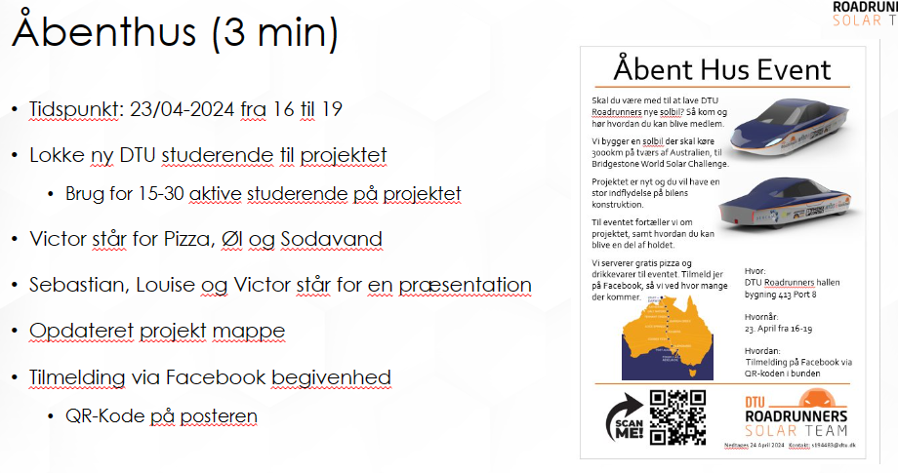

**Wiki and CAD**

We have a messy wiki right now

We need to formalize it, so its futureproof, and minimize the complexity of the CAD file of the car, and have a history of the car

DTU IT are planning to roll out 3d solidworks, we can take a look later when it's more developed

We do it by:

Component QR code - three different groups assembly, CAdfile and component (to minimize how many pages we need, for similar components)(two ids CAD and component)

It isn't completely done.

Not only for mechanical stuff - if you can do it we make a QR code for PCB’s

**Project updates**

**Anders**

Test for the frame for the battery went good (3 times), and need one more test and then they are good.

Motors, we got all three motors delivered, testbench are ready, waiting for motor speed controller

Side View mirrors are on hold waiting for supervisor

**Victor (mek)**

Almost done with front and rear suspension testing

**Windshield wiper**

In the progress of finding motor and finding a windshield arm

**Wheel rim**

Focusing a design for CNC milling, in a alloy (aluminum)

**Victor(Battery)**

Battery test with two students, is progressing

Trying to contact solarcell seller.

**Steering**

Steering rack ordered, need to do some calculating

**Front light**

Ordered all lights, and working on PCB

**Back light**

Ordered all lights, and working on PCB and scavenging old PCB files to use in their work.

**Cabin cooling**

CFD simulations to explore the pressure, and looking at alternative ways to do it. And looking for fans to buy.

**Mechanical side view mirror**

Doing simulations, the next step is positing and tensile test.

Talk with anders about mounting spots for a side view mirror (digital and mechanical)

**Other**

Sign up for ilumen (31 august sign up)

Socializing event in the summer

**Feedback**

Change to english

Next meeting

Management 16/04

Generel 07/06